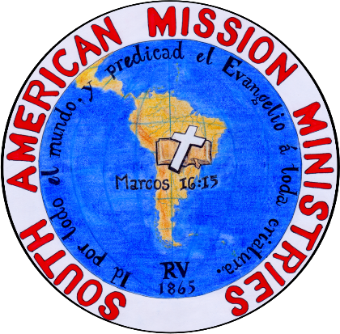
Copacabana, Antioquia, Colombia
August 3, 2025

Beloved brethren,
Time passes rapidly, and nevertheless the work of God continues to be the focus.

These last months we have seen the hand of God on our work in a magnificent way. God always surprises us.
In April, we had our annual conference in which we were visited by brethren from Marinilla, Montenegro and the Amazon. The fellowship with the brethren was a great blessing. The church in Copacabana worked hard for this conference, and we had great attendance to the services.
In May, the church in Copacabana said its good-byes to my son Andrés who would soon marry his bride Fanny in June. The wedding was performed in the United States. Sister Fanny is part of la Iglesia Bíblica Bautista de Hialeah. Even though it was sad to see my son go, it is a blessing to know he is serving in his church in Miami with his wife.
Also in May, we had five brethren be baptized, three from Copacabana (Emanuel, Waldir y Ramón) and two from the mission in Barbosa (Germán and María). Other people that attended the baptisms asked to be baptized in next opportunity. Brother Germán is the first baptism from la Misión Bíblica Bautista in Barbosa.
I was invited to preach at a small mission in the village of La Estrella. Some women and their grandchildren attend there. The youth were very attentive to the preaching of the word. It was a difficult location to Access, but God helped us and it was a great blessing to bring the message to this village.
In July, we finished the printing of the book “Sermones edificantes”, of which SAMM helped to produce. I asked at the city hall of my town if it would be possible to do a release of the book in a cultural house, and the government of my town responded in the affirmative. Thus, on July 17, we did the release with large attendance in a municipal building. Our temple does not have the capacity to hold events that would surpass 100 attendees.
Soon afterward, on July 20 we celebrated 20 years of preaching in Copacabana. We had to rent a space that could host 150 attendees. We give glory to God that, in Copacabana, we have grown and now need more space.
Equally, we have supported la Iglesia Bíblica Bautista de Marinilla, la Iglesia Bíblica Bautista de Montenegro, la Iglesia Bautista Peniel de Santa Rosa Perú, la Iglesia Bíblica Bautista de Arequipa Perú, and la Iglesia Bíblica Bautista la Roca de Cali (Colombia). Our ministry has expanded, and we hope to continue serving the Lord until He returns and catches us away.
The Bible Institute continues onward. Pastor Manuel Hernández has helped this year with two courses. This past Monday we started a new course with students from Colombia and Peru.
We ask for prayer for: Renting a location in Barbosa for the mission (there are three families that attend and two that have been baptized), that the conditions at the church in Copacabana improve (as we have little space), the ordination of Pastor Eduard Betancur in Montenegro (the church chose their pastor on August 3), a future visit to the Amazon, and also one to Arequipa.
Let us continue stedfast, unmovable in Christ Jesus.
Fabio Carballo
Pastor, Iglesia Bíblica Bautista de Copacabana.
Translated by Pastor Manuel Hernandez

